|  |
| --- |
|  |
| 新概念 3 册 |
| Lesson42 |

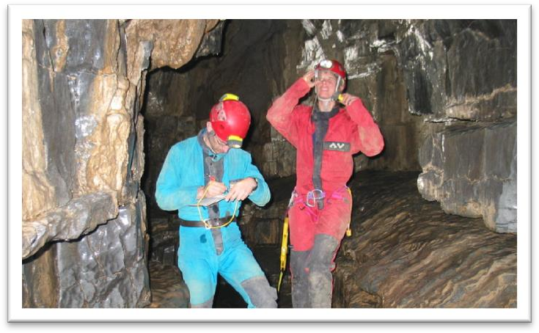Lesson 42 Modern cavemen

**solitude ['sɒlɪtju:d]**

**n. 单独, 独自**

Perhaps it is the desire for solitude or the chance of making an unexpected discovery that lures people down to the depths of the earth.

I love tranquil solitude.

— P. B. Shelley

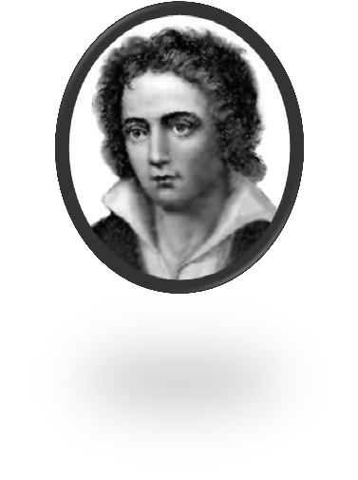

in solitude

I spent the morning in solitude.

I live in that solitude which is painful in youth, but delicious in the years of maturity.

— Albert Einstein

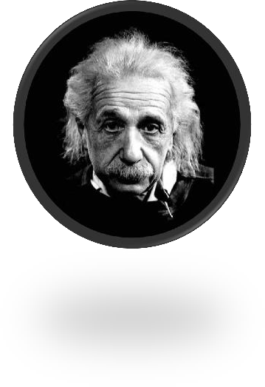

solitary

They had a single aim, a solitary goal—the top!

*all* (alone / on one’s own / by oneself )

lure [lʊə(r)]

**v. 引诱，诱惑**

lure sb. to / into some place

He lured the victim into a deserted house.

Perhaps it is the desire for solitude or the chance of making an unexpected discovery that lures people down to the depths of the earth.

lure sb. into doing

tempt sb. to do / into doing entice sb. to do / into doing **foresight ['fɔ:saɪt]**

n. 远见, 先见之明

foresight n. 远见, 先见之明

They had the foresight to invest in new technology.

Such undertakings require the precise planning and foresight of military operations. forethought n. 远虑，提前的思考

With a little forethought many accidents could be avoided. forecast n. 预测，预报

weather forecast

foresee vt. (foresaw, foreseen) 预见……

Bagrit foresaw a time when computers would be small enough to hold in the hand, …

Of course, Leon Bagrit could not possibly have foreseen the development of the Internet, … The telephone rings and this marks the prelude to an unforeseen series of catastrophes. foretell / predict v. 预言……

Precautions of this sort are necessary, for it is impossible to foretell the exact nature of the difficulties which will confront the pot-holer.

Considering how recent these developments are, it is even more remarkable that as long ago as the 1960s, an Englishman, Leon Bagrit, was able to predict some of the uses of computers which

we know today.

Timely snow foretells a bumper harvest. mark the prelude to sth. 预示……

The telephone rings and this marks the prelude to an unforeseen series of catastrophes.

insistent [ɪn'sɪstənt]

**adj. 声音持续不断的；坚持要求的**insistent adj. 1. 声音持续不断的the insistent ringing of the phone insistent adj. 2. 坚持要求的

be insistent on sth.

be insistent that + S. + (should) do insist on sth.

insist that + S. + (should) do

Even though the noble was expected to read the letter at each performance, he always insisted that it *should* be written out in full.

persist in … / with … 坚持不懈persistent adj. 坚持不懈的consist of … 由……组成

Though the costume consisted only of a sheet, it was very effective. be consistent with … 与……符合，前后一致

resist v. 抵制，抵抗

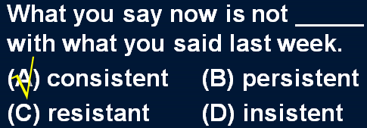be resistant to sth. 抗……，反对……

glisten ['glɪsn]

**v. 闪光，闪烁**

flash v.& n.

a flash of lightning

Sparks were emitted from small black boxes and red lamps flashed on and off angrily. flicker v.& n.

The candle flickered in the wind.

These lights flickered continuously like traffic lights which have gone mad. glow v. & n.

The heated iron bar glowed.

There is something comforting about the warm glow shed by advertisements on cold wet winter nights.

twinkle v.& n.

Twinkle, twinkle, little star, like a diamond in the sky.

— Jane Taylor



sparkle / glitter / glint v. & n.

The diamond sparkled in the sunlight. All that glitters is not gold.

— Shakespeare

Nothing can be compared, he maintains, with the first cockcrow, the twittering of birds at dawn, the sight of the rising sun glinting on the trees and pastures.

glisten v.

His face glistened with sweat. Her eyes glistened with tears.

Round about, piles of limestone glistened in all the colours of the rainbow.

Cave exploration, or pot-holing, *as it has come to be known*, is a relatively new sport. Football, or soccer, *as it is sometimes called*, is very popular in the world.

Things can go wrong on a big scale, as a number of people recently discovered in Parramatta, a suburb of Sydney.

As the Commanding Officer explained later, one half of the station did not know what the other half was doing!

If, as has been reported, they have protected humans from sharks, it may have been because curiosity attracted them and because the scent of a possible meal attracted the sharks.

As is so often pointed out, knowledge is a two-edged weapon which can be used equally for good or evil.

Cave exploration, or pot-holing, as (it) has come to be known, is a relatively new sport. The problem, as I see *it*, is no big deal.

The author was brought up in a small village, as *it* is recounted in some of his stories.

Future historians will be in a unique position when they come to record the history of our own times.

He soon made a name for himself and came to be known to the Italians as Giovanni Acuto. A body came to be found under the bridge.

造句：H1N1 流感, 或称猪流感 (swine flu), 正如人们逐渐了解的那样，是一种高度传染性

(highly contagious) 但可防可控可治 (preventable, controllable and curable) 的疾病。H1N1 flu, or swine flu, as it has come to be known, is a highly contagious but preventable, controllable and curable disease.

Perhaps *it is* the desire for solitude or the chance of making an unexpected discovery *that* lures

people down to the depths of the earth. desire for ... appetite for ...

lust for ... longing for ...

yearning for ... craving for ... hunger / thirst for ...

the depths of the earth the depths of the ocean the depths of the space the depths of the forest the depths of despair

造句：正是对知识的渴诱使他走进了科学的世界。

It is the desire *for* knowledge that lures him to the scientific world. give a satisfactory / convincing / logical / … explanation for sth. defy explanation

owe sb. an explanation

I feel like I owe you an explanation. I don't ordinarily go around kissing guys at parties. it is impossible to give a satisfactory explanation for …

it has never been explained why …

造句：谁也无法解释为何玛雅文明从地球上突然消失。

It has never been explained why Maya civilization vanished from the earth.

It is impossible to give a satisfactory explanation for the disappearance of Maya civilization. have a / an *peculiar / extraordinary / unfailing* fascination for …

Mars has an extraordinary fascination for would-be voyagers. Cats have an unfailing fascination for most people.

*For him*, caves have the same peculiar fascination which high mountains have *for the climber*. 造句：书对他有一种独特的吸引力，就像化妆品 (cosmetics) 对他老婆的吸引力一样。For him, books have the same peculiar fascination which cosmetics have for his wife.

Antique shops exert a peculiar fascination on a great many people. exert a … fascination on sb.

have a … fascination for sb.

造句：我很喜欢集邮 (stamp collecting)。

Stamp colleting exerts a peculiar fascination on me. Stamp collecting has a peculiar fascination for me. dim / dimly 昏暗的/地，朦胧的/地

Then, squinting his eyes, he said: 'The light is dim. Read the letter to me'. sth. can only be dimly understood

it is impossible to give a satisfactory explanation for sth.

造句：他的行为很难理解。

His behavior can only be dimly understood.

It is impossible to give a satisfactory explanation for his behavior. Horses *are* useful animals.

The horse *is* a useful animal. A horse *is* a useful animal.

… is not a task for sb. ……不是某人所能胜任的

造句：出国留学不是懒汉 (lazy-bones) 所能胜任的。

Studying abroad is not a task for the lazy-bones. 造句：做个好老公不是花花公子能胜任的。Being a good husband is not a task for the playboy. require the precise planning and foresight of …

造句：炒股 (speculation in stocks) 需要一个职业投资人的精密计划和远见。Speculation in stocks requires the precise planning and foresight of a professional investor. For them this is a major operation which involves considerable planning.

造句：出国留学是一个重大行动，需要大量精心的计划。

Studying abroad is a major operation which involves considerable planning.

It can take as long as eight days *to rig up rope ladders and to establish supply bases* before a descent can be made into a very deep cave.

The wound will take a long time to heal. It takes two people to make a quarrel.

You’re an idiot!

*It takes one to know one* !

Anyone can be passionate, but it takes real lovers to be silly.

— Rose Franken

it takes … to do sth.

造句：做一名长跑运动员需要耐力(stamina)。

It takes stamina to be a long-distance runner.

造句：反抗 (stand up to …) 老板需要很大的勇气。

It takes a lot of courage to stand up to the boss.

造句：照顾一名残疾儿童需要很大的耐心。

It takes a lot of patience to take care of a disabled child.

rig up: to make sth. quickly out of whatever you can find 草草做成，草草搭起

They rigged up a shelter using a sheet and some branches. make a descent = descend

... before pot-holers can descend into a very deep cave.

Precautions of this sort are necessary, for it is impossible *to foretell the exact nature of the difficulties which will confront the pot-holer*.

precaution n. 预防措施

fire / safety / security / sanitary precautions take precautions

The government took precautions to prevent the spread of the disease. take measures

take effective / drastic measures Precautions of this sort *are* necessary, … This sort of precaution *is* necessary, … confront / face sb.

be confronted / faced with ... known

little-known unknown well-known

extend to a depth of ...

The platforms extend to a depth of over 100 feet under the sea. rise to a height of ...

Above the surface of the water, the towers rise to a height of nearly 700 feet. be / stand … high / tall

be … deep / in depth be … long / in length

be … wide / across / in width

This immense chasm has been formed *by an underground stream which has tunneled a course through a flaw in the rocks*.

chasm n. 深渊，峡谷

It is a world of red sandy deserts (hence its name — the Red Planet), cloudless skies, savage sandstorms, chasms wider than the Grand Canyon and at least one mountain more than twice as tall as Everest.

tunnel plateau

the Qinghai-Tibet Plateau plain

the North China Plain

basin the Tarim Basin

savannah prairie grassland the Inner Mongolian Grassland

The cave might never have been discovered had not the entrance been spotted by the distinguished French pot-holer, *Berger*.

The cave might never have been discovered if the entrance had not been spotted by the distinguished French pot-holer, Berger.

If + S. + did / were, S. + would / should / could / might + do

If + S. + had done, S. + would / should / could / might + have done If + S.+ should do, S.+ would / should / could / might + do

If + S.+ did / were to do, S.+ would / should / could / might + do

were had should

If I were you, I would go abroad at once. Were I you, I would go abroad at once.

If you had come here a little earlier just now, you might have met her. Had you come here a little earlier just now, you might have met her. If it should rain tomorrow, you could stay at home.

Should it rain tomorrow, you could stay at home.

If the sun were to rise in the west, I would lend you the money. Were the sun to rise in the west, I would lend you the money.

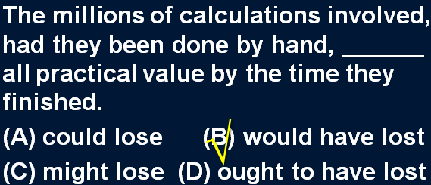

a sort / kind of ...

We sometimes imagine a desert island to be a sort of paradise where the sun always shines. In spite of this, the Italians regarded him as a sort of hero.

They will be able, as it were, to see and hear us in action.

Since its discovery, it has become, as it were, the pot-holer’s Everest. Since its discovery, it has become, so to speak, the pot-holer’s Everest. remain to be done 有待……

Several problems remain to be settled.

It remains to be seen how many senior citizens will actually benefit from this new plan.

They had to edge their way along this, sometimes wading across shallow streams, or swimming across deep pools.

edge one’s way

**squeeze one’s way**

**squeeze through / in / past / by ..**.

Squeezing through a cleft in the rocks, the pot-holers arrived at an enormous cavern, the size of a huge concert hall.

make one’s way

The hospital had been bombed and Hans had made his way back into Western Germany on foot.

find one’s way

Very few of the fifty pence pieces and pound coins I have given him have found their way there. They had mysteriously found their way there from the wine cellar!

trace / weave / wind one’s way

We expected the path to end abruptly, but we found that it traced its way through the trees.

force / elbow one’s way feel one’s way

**tunnel one’s way**

They plunged into the lake, *and* after loading their gear on an inflatable rubber dinghy, (they) let the current carry them to the other side.

plunge into … “扑通”跃入水中

The order to abandon ship was given and hundreds of people plunged into the icy water.

In this part of the cave, they could hear an insistent booming sound *which they found was caused by a small waterspout (shooting down into a pool from the roof of the cave)*.

造句：她有一个养子，这个养子据她讲是个孤儿。

She has an adopted son who *she says* is an orphan.

造句：Aleko 突然得到了一只新的羊羔，这只羊羔他声称是买来的。

Aleko suddenly acquired a new lamb which *he claimed* was bought. He’s just published an article which *I don’t think* is interesting at all. I met a man whom *I thought* was a lunatic.

After switching on powerful arc lights, they saw great stalagmites— *some of them over forty feet high*— rising up like tree-trunks to meet the stalactites suspended from the roof.

switch on ↔ sth. switch off ↔ sth.

... — some of them being over forty feet high — ...

造句：在打开灯之后, 我看到在一个小黑盒子里面装着闪闪发光的 (sparkling) 钻石, 其中有些有玻璃球 (marbles) 那么大。

After switching on the light, I saw sparkling diamonds—some of them as big as marbles—contained in a small black box.

In the eerie silence of the cavern, the only sound that could be heard was made by water *which dripped continuously from the high dome above them*.

造句：在这栋房子可怕的寂静中, 唯一能听到的声音就是从一扇打碎的窗子不断吹进 (blow)

的风声。

In the eerie silence of the house, the only sound that could be heard was made by wind which blew continuously from a broken window.